Ideation Phase

Define the Problem Statements

|  |  |
| --- | --- |
| Date | 10 November 2022 |
| Team ID | PNT2022TMID12796 |
| Project Name | Industry-specific intelligent fire management system |
| Maximum Marks | 2 Marks |

**Problem Statement-1:**

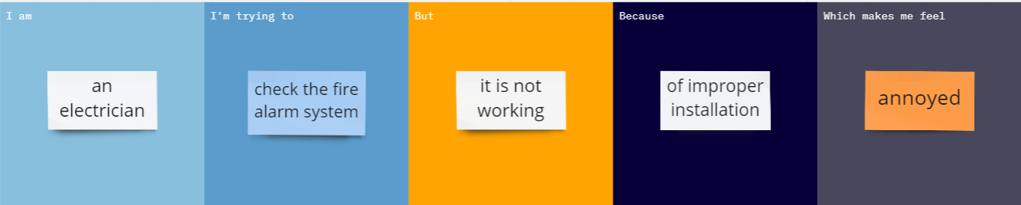

**Problem Statement-2:**

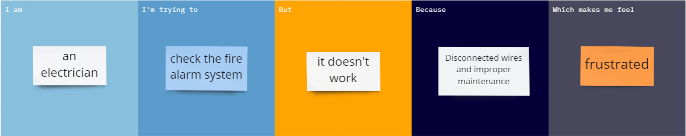

|  |  |  |  |  |  |
| --- | --- | --- | --- | --- | --- |
| **Problem Statement (PS)** | **I am (Customer)** | **I’m trying to** | **But** | **Because** | **Which makes me feel** |
| PS-1 | an electrician | check the fire alarm system | it is not working | of improper installation | annoyed |
| PS-2 | an electrician | check the fire alarm system | it doesn’t work | Disconnected wires and improper maintenance | frustrated |